





1. **Open Android Studio**
   * Launch Android Studio and open your project or create a new one.
2. **Add the Necessary Permissions**
   * In AndroidManifest.xml, add the following permission:<uses-permission android:name="android.permission.POST_NOTIFICATIONS"/>
3. **Create or Edit the XML Layout File**
   * Add a **Button** in your layout that will trigger the notification.
4. **Go to the Corresponding Activity/Fragment**
   * Navigate to the .java or .kt file linked to your layout.
5. **Initialize the Button in Code**
   * Use findViewById() to reference the Button in your Activity/Fragment.
6. **Create a Notification Channel** (For Android 8.0 and above)
   * Use NotificationChannel with properties like **ID**, **Name**, and **Importance**.
   * Register the channel using NotificationManager.
7. **Build the Notification**
   * Use NotificationCompat.Builder to create the notification.
   * Set properties like **title**, **text**, **icon**, and **priority**.
8. **Set Up a Pending Intent** (Optional)
   * Create an Intent to define what happens when the notification is clicked.
   * Wrap the intent in a PendingIntent.
9. **Trigger the Notification**









**Implementation Phase: Final Output(no error)**

**Step 1: Design the Layout**

* Open activity_main.xml from the **res → layout** folder.

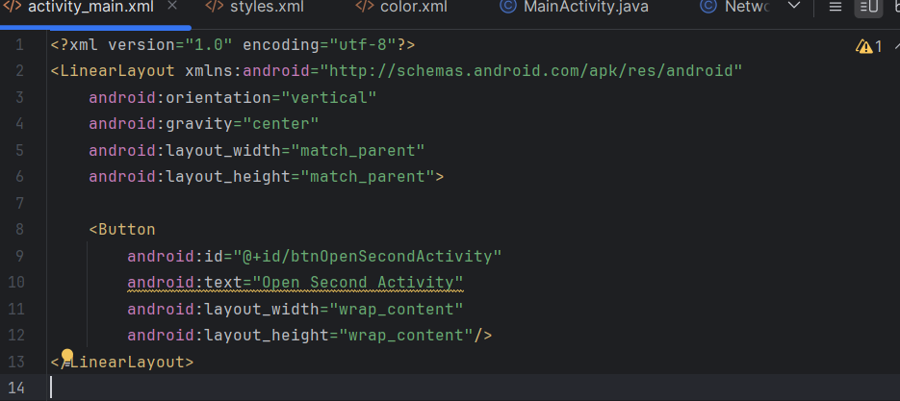

**Configuring styles.xml (For Custom Theme/Style)**

**Location:** res → values → styles.xml

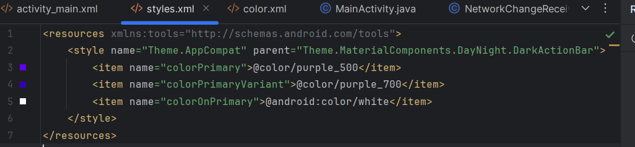

**Configuring colors.xml (For Custom Theme/colors)**

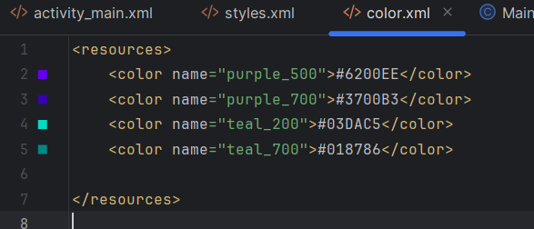



**Implementation Phase: Final Output(no error)**

Open AndroidManifest.xml in the app → src → main folder.

add android:exported="true" to the activity tag with an intent filter.

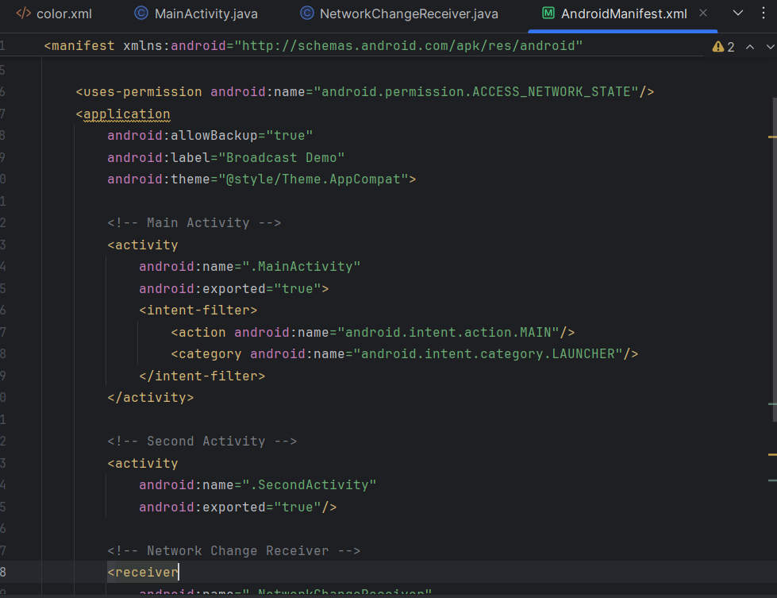

**Configuring Mainactivity.java**

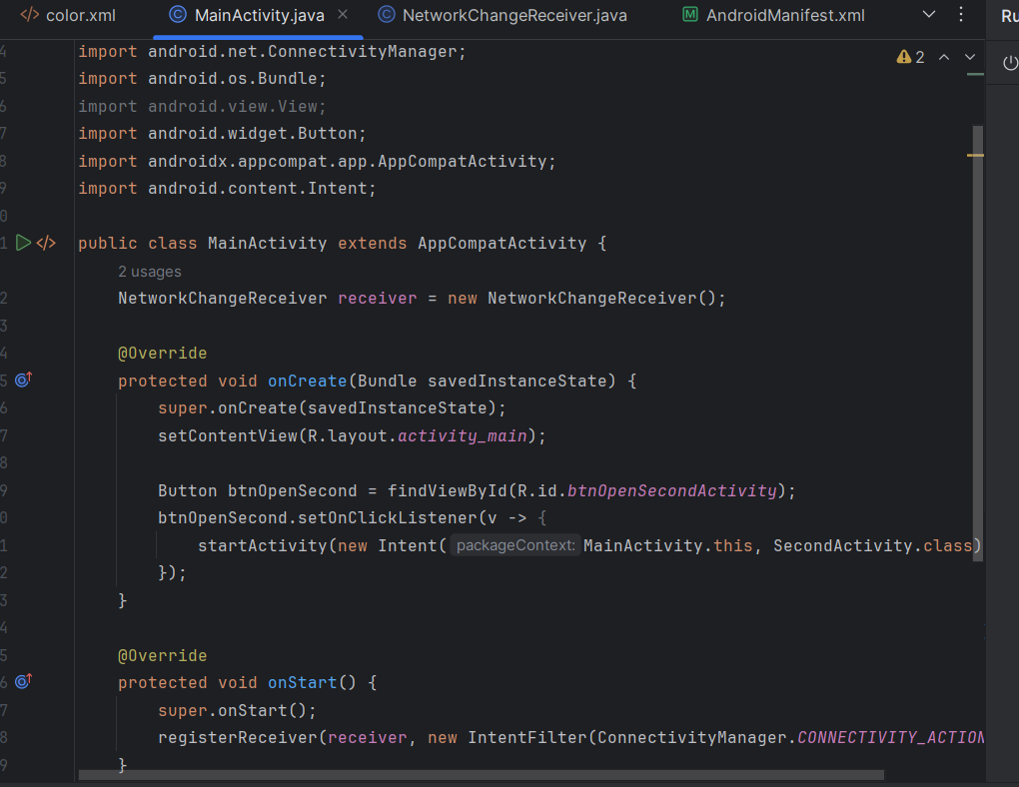



Click **Run** .





        
        
        
        
        
        
        
        
        



